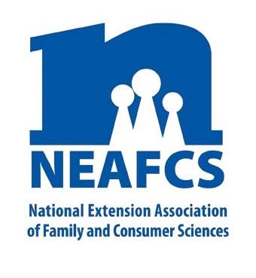
IMPACT 2014

Through Extension programs across the nation, Family and Consumer Science Extension Educators provide a multitude of educational opportunities to meet the needs of diverse audiences.

Improving Children’s Lives

Extension delivers a multitude of educational programs aimed at helping parents do their best to enable their children to live healthy, productive and successful lives. FCS educators also work closely with childcare providers, school teachers, and other adult youth workers and organizations intent on providing safe and supportive learning environments for the children in their care.

Early Child Care and Safety

In Arizona, seven different programs, reaching over 28,000 people are offering classes with a variety of subjects, all aimed at improving the lives of children. First Smiles is a program that screens children for tooth decay and offers training to professionals about the seriousness of tooth decay. Brain Builders for Life is another program for childcare providers that include developmental and sensory screening, dental screening, and early brain development training for professionals.

In West Virginia, 128 programs focused on child abuse prevention for parents and childcare providers. Additionally, 4-H day camps were provided for the children. Delaware FCS educators partnered with Prevent Child Abuse Delaware to present “Bullying--What to Do” and “Tigger, Pooh or Piglet: Understanding Temperament.” Other childcare providers learned how to create eco-green-friendly early childcare settings.

NEAFCS National Office | 20423 State Road 7, Suite F6-491 | Boca Raton, FL 33498
(561) 477-8100 | FAX (561) 910-0896 | www.neafcs.org
In Mississippi, the Child Care Resource and Referral Network has been presenting trainings to 140 early childcare center directors. The trainings include the

latest concepts in early childcare curriculum and day-to-day operations of their centers.

Trainings offered to Kansas childcare providers focused on physical activity, nutrition education, child abuse and neglect, as well as social and emotional development. “Day-camp” opportunities were also offered for children and parents to strengthen the family unit and its support systems. Results showed that childcare center directors now feel more confident in their ability to discuss family related issues.

“I had no idea that my children were affected by the way I talk with and about my former spouse. Using ‘when-then’ has made a difference in our home.” – Ohio Parent

In Maine, FCS educators presented “Stress and Children” programs to 50 early childcare providers to understand signs or stress in themselves and in children, as well as strategies for dealing with stress.

Parenting Education

In Utah, 1,000 programs with over 42,000 participants were focused on improving children’s lives. Love and Love Step-Family classes helped build relationships and foster health family values for both parents and children. In Pennsylvania, online and direct programs have reached over 750,000 people using Better Kid’s Care on Demand, as well as community based workshops.

In Nebraska, direct and online resources are guiding healthy families. Resources such as “U R Parent App” and “Co-Parenting for Successful Kids” classes are being utilized. There has been an increase in understanding about how a parent’s actions influence children’s adjustments to divorce.

In Ohio, FCS programs help parents learn how to communicate peacefully within the family. In Vermont, the Vermont Kin as Parents or VKAP “Across the Fence” program - a daily farm and home television show - attracted 52,000 viewers.

In New York, 50 parenting workshops reached over 735 parents, helping them incorporate fundamental skills and techniques for successful parenting. Nine out of ten pre/post-test indicators improved significantly- increasing patience, confident rule-making, explanation for rules, and time reading with their child.

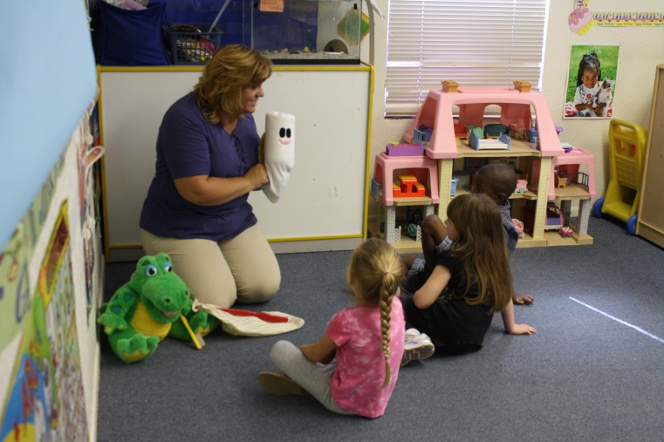
Afterschool/Enrichment Programs

Eight Tennessee afterschool programs served 800 children teaching reading, science, math, technology, health, socialization and leadership to students through hands-on, experiential activities. The program is making great strides in social/emotional development
in children, which is a strong predictor of school readiness.

Over 100 programs in New Mexico, based on improving knowledge and skills, taught youth about fitness, nutrition, safety, substance abuse, and sewing.

In Iowa, Extension-trained volunteers talked with Latino families to discuss bridging the gap between high-school and college. This six-week program helped these families gain the knowledge and skills needed to be successful during this time of transition.

This report was compiled by Liz Kingsland, University of Kentucky Cooperative Extension, Public Affairs Education Subcommittee member, and Theresa Mayhew, Cornell Cooperative Extension, Vice President – Public Affairs. For more information, email tcm5@cornell.edu.

